# Building & Structure Numbering Standard

Version Date: April 2019

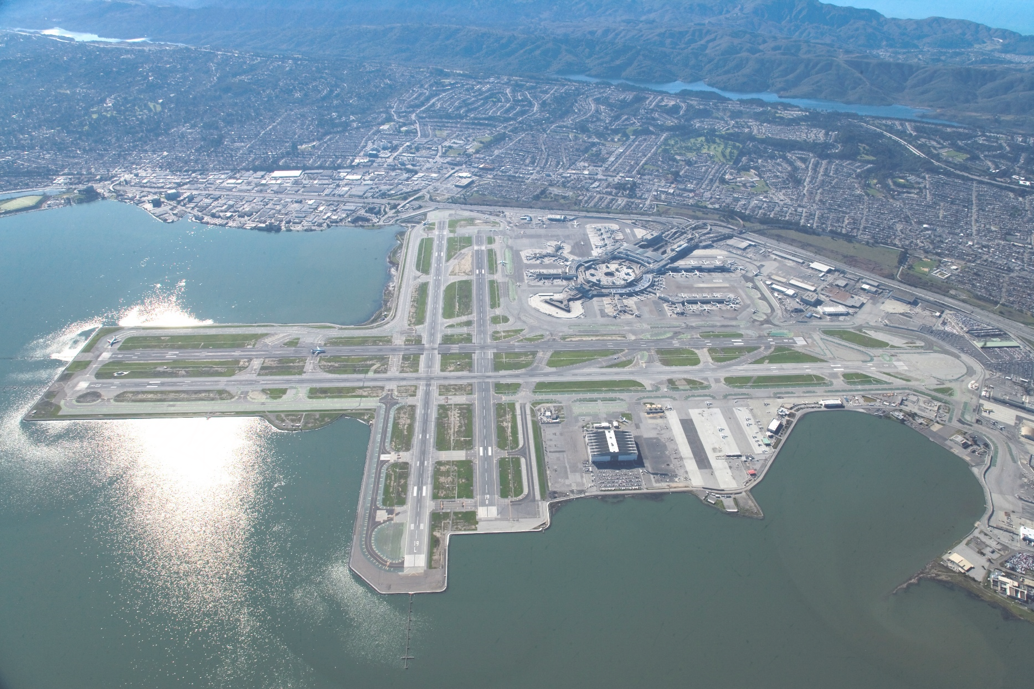

# Introduction

* 1. The purpose of this document is to define the San Francisco International Airport (SFO or Airport) Building and Structure Numbering Standards, as well as define what shall be considered as a building or structure. Numbering standards shall be utilized to ensure continuity of the Airport’s building and structure numbering and to help maintain the integrity of the Airport’s spatial data infrastructure.
  2. The numbering convention will adopt the current numbering scheme in order to preserve existing building ID’s yet also provide the opportunity to expand with future growth. Buildings are currently numbered in a clockwise sequence around the property, which is to remain in place with the addition of zones to provide a spatial structure to the numbering convention.

# Definitions

* 1. Building Number
     1. Building number is not to be confused with building name. Building numbers are to be numeric or in some cases alpha-numeric and will always be unique. A building number is assigned in accordance to the methodology prescribed within this document. Building name is a more colloquial version that many use to identify a building, such as “TWA Hangar”. Building names will and can change and are acceptable so long as each building has a unique building number associated with it as well.
  2. Spatial Extent
     1. The spatial extent of this numbering convention is, but is not limited to the property line boundaries of San Francisco International Airport. For those areas not within the property line but are adjacent this numbering convention may apply so long as the building or structure belongs to SFO and there is no other convention in place.
  3. Zones
     1. Building numbers will be organized into building number zones. Zones have been organized around the existing building numbering scheme which will allow the organized addition of new building numbers without compromising pre-existing building numbers. Zone boundaries have been organized in such a fashion to follow SFO’s property lines.
  4. Buildings
     1. A building, for the purpose of naming, is a structure with a roof, walls, an entry point, and is permanent in nature. A typical building will have a foundation and can be one or more levels. A building can be used for human activities or for storage.
  5. Structures
     1. A structure falls outside the scope of what is considered a building. Structures can have a roof and/or walls but it is not required. Structures can be used for human activities or storage. Structures can be permanent or temporary and do not require a foundation or other traditional building elements. Structures can have one or more levels. Examples of a structure can be but are not limited to:
        + A shipping container
        + A bus stop
        + A lean-to, a car-port or an overhang structure
  6. Out-of-the-scope – Structures that are already are numbered via another numbering convention.
     1. Buildings and structures that have pre-existing naming conventions and or placards in place shall not be considered in this naming convention. If it is determined that a structure or building type that currently follows the methodology put forth in this document is no longer suitable for any reason, it may be retired from the current methodology and adapted to another. Please contact the proper authority if a building or structure type is being considered for a different naming convention for approval.
     2. Examples of SFO structure types that will not participate in this methodology are:
        + Industrial waste pump-stations. (‘IWS’)
        + Electrical load-centers. (‘BB’)
        + United States Coast Guard Air Station San Francisco buildings and structures.
        + United Airlines Maintenance Operations Center San Francisco (M.O.C.) buildings and structures.

1. Any structure that is participating in another, known numbering convention will be mapped and recorded using that convention and therefore falls outside of the standard numbering convention used by SFO. Examples of such structures are USCG, FAA equipment, pump stations and United Airlines maintenance operations center (MOC).
   1. Primary buildings or structures
      1. Primary
2. A main building that serves the airport in a primary role or roles. This type of building does not support the function of another building as its primary purpose.
   * 1. Support
3. A support building’s sole purpose is to provide support or extend the use of a primary building.
   * 1. Secondary
4. Any structure that is not deemed a primary building or support structure can be considered a secondary building. If a secondary type building is participating in any other naming convention, such as FAA equipment or USCG structures, then it is not necessary to number these structures.

# Numbering Conventions

* 1. Zones (see Diagram 1)
     1. The airport numbering zones shall range from 99 – 1400 with the addition or sub-division of zones available if the need arises. A notable exception to zone numbers will be zone 1019 where all buildings within the zone will adopt a preexisting numbering convention put in place by the USCG. Zones will follow the preexisting logical pattern of building numbers throughout the airport. Zones will typically contain 100 available primary building numbers each. If a zone surpasses 100 primary buildings then a subdivision of that zone may be applied.
     2. Buildings and structures that fall outside of the zones but are not greater than 1mile in distance from a zone edge may be attached to the zone it is nearest to. E.g.: Middle marker structure located in the Bay water outside of zone 1100.
     3. Any buildings or structures that fall at least 1 mile outside the standard zones are to be considered as remote. Remote buildings may be numbered but it is not mandatory.
  2. Ownership
     1. All buildings and Structures on SFO property shall receive a designation. A number assignment is needed regardless of ownership. Buildings and structures owned by SFO but outside of the property lines may be subject to numbering but not required.
  3. Buildings
     1. Primary buildings
        + Primary buildings will assume the zone number in which they are located in and are to be names in sequential order throughout the zone. When possible primary building numbers will follow a clockwise fashion, in ascending order, around the airport (with the VOR or intersection of the 4 runways serving as the center) starting with Zone 99. Zone 99 shall consist of all buildings ranging from 1-99. When possible there should be proper spacing of numbers between buildings in order to accommodate future growth and infill. If a building were to be moved from one zone to another (e.g. a mobile building) it will be re-numbered accordingly.
     2. Support buildings
        + Support buildings will assume the number of the building which they support followed by an alpha character. An example would be a support structure for building 1060 would be 1060A. Starting from the southernmost corner of the primary building the support structures should start with “A” and mover in a clockwise fashion around the building. If a support structure reaches the letter “Z”, then a double alpha designation can begin, e.g.; 1060AA, 1060BB and so on.
     3. Secondary buildings
        + Secondary buildings will always begin with the letter “S” followed by the four-digit zone number of which it is in, followed by a unique building ID. An example of this would be a structure in zone 700, which is assuming a secondary structure number of 15 would be known as “S070015”.

# Workflow Process for Building and Structure Additions, Deletions, Edits, and Archives (see Diagram 2)

* 1. Originator makes request
  2. IIM acknowledges request and requests site plan
  3. IIM cross checks database for number availability and assigns number in the system
     1. Spatial continuity check is performed
  4. Request is logged in an IIM maintain request database
  5. Site plan mark-up with proposed building numbers
  6. Stakeholder review
     1. Marked up site plan is forwarded to
        + Airfield Operations (for AOA buildings)
        + Aviation Management (for all buildings)
  7. Stakeholder approval(s)
  8. Formal issuance of number procedure begins:
     1. GIS database is updated and structure geometry is added
     2. Notification via email is provided to the originator
     3. Active notification begins to the following:

SFO Aviation Management – [Viviana.Soper@flysfo.com](mailto:Viviana.Soper@flysfo.com), [Eric.Yee@flysfo.com](mailto:Eric.Yee@flysfo.com)

SFO Fire Department – per ERF

SFO Police, Airport Bureau – TBD

SFO Airfield Operations – [Glenn.Brotman@flysfo.com](mailto:Glenn.Brotman@flysfo.com), [Drake.Poston@flysfo.com](mailto:Drake.Poston@flysfo.com)

SFO Communications (911 system) - [Reginald.Saunders@flysfo.com](mailto:Reginald.Saunders@flysfo.com), [William.Adams@flysfo.com](mailto:william.adams@flysfo.com)

SFO Facilities and Maintenance – [joyce.allegro@flysfo.com](mailto:joyce.allegro@flysfo.com), [constance.fitzgerald@flysfo.com](mailto:constance.fitzgerald@flysfo.com)

SFO Duty Managers [SFOADMS@flysfo.com](mailto:SFOADMS@flysfo.com)

SFO Project Manager (if applicable)

SFO Communications & Marketing – [Charles.Scheduler@flysfo.com](mailto:Charles.Schuler@flysfo.com) (if applicable)

United States Post Office (if building number is Primary) - [eddie.n.masangcay@usps.gov](mailto:eddie.n.masangcay@usps.gov), [david.w.jones@usps.gov](mailto:david.w.jones@usps.gov), [isidore.d.szczepaniak@usps.gov](mailto:isidore.d.szczepaniak@usps.gov)

* + 1. Passive notification:

1. Updating of applicable databases
2. Updating of SFO base-maps and applications
3. Updating of FLYSFO and/or SFO Connect (if applicable)
4. System-wide email notification (if applicable)
   1. Create work order request for building/structure sign to be fabricated and installed by Airport Sign Shop (if necessary)
   2. (Google Map Update – need to coordinate with Charles Schuler)
   3. Request is logged as close in structures database
   4. Once building is issued a certificate of occupancy SFO IIM will take site photos of structure(s) for the database

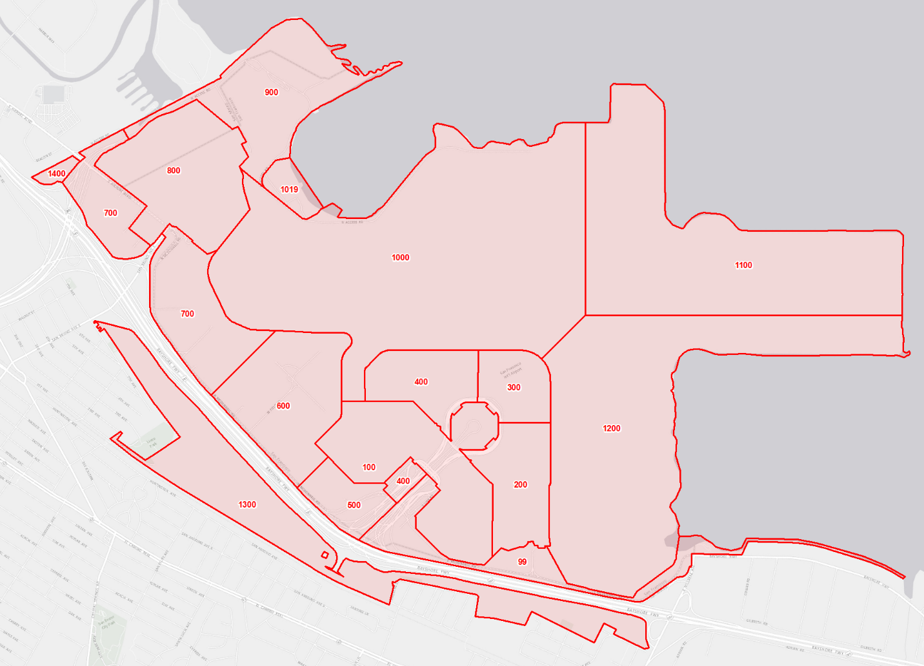**Diagram 1: SFO Structure Numbering Zones.**

**Diagram 2: Structure Numbering Flow-chart**

05/19/2017

**Submittal**

* Email
* Include Diagram Attachment
  + If no architectural diagram is available indicate building(s)/structure(s) footprint on the Airport basemap or Google map
  + Footprints should be shown with best estimation of their geometry, dimensions, and orientation
* Description
  + Brief description and usage of the building(s)/structure(s)
* Dates (list out per each building/structure)
  + Construction start and end
  + Occupancy start and end
  + Occupants
* Mail Service Requested: Y/N

**Acceptance**

* Formal acceptance of drawing by committee
* Notification of acceptance to committee and design team.

**SFO Initial Internal Review**

* Proposed drawing will be dispersed to the SFO space numbering committee
* Committee Consists of:
  + SFO IIM
  + SFO Architecture
  + SFO Aviation Management
  + SFO Mechanical Maintenance
* Committee members will review drawing(s) individually
* Committee Chairperson will schedule a joint review session if needed
  + Joint review consists of:
    - SFO committee members
    - Design team members

**Design Review (if needed)**

* Review session between SFO committee and the design team. This meeting is designed so that if the committee has questions or concerns about space numbering and methodology then they can be addressed or guidance may be provided.

**Building/Structure Numbering Request Form**

Batch all building/structure requests under the same project/contract as this context enables us to develop proper numbering. Please provide the following information:

* Vicinity map in PDF
  + Indicate building(s)/structure(s) footprint on the Airport basemap or Google map
  + Footprints should be shown with best estimation of their geometry, dimensions, and orientation
* Description
  + Brief description and usage of the building(s)/structure(s)
* Dates (list out per each building/structure)
  + Construction start and end
  + Occupancy start and end
  + Occupants
* Mail Service Requested: Y/N